**CN LAB 2**

**23K-0594 (SEC 5F)**

**Task1:**

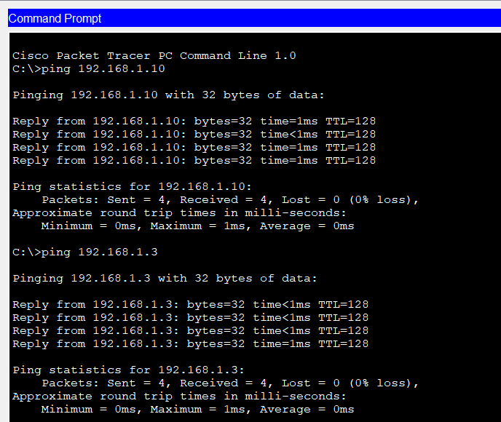

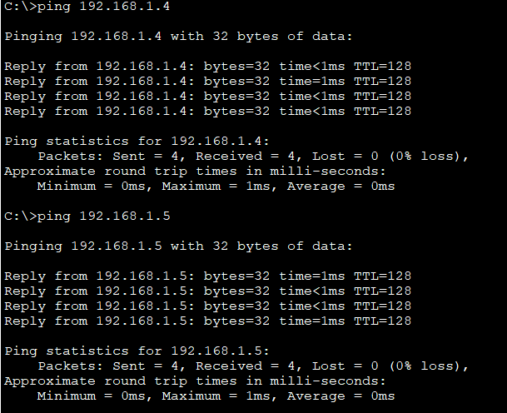

Similarly done for all other PCs to test connectivity.

**Functionality of Devices:**

1. PCsare (End-user) devices that send and receive data packets across network (like requests to the server).
2. Server provides network services (e.g., Web, DNS, DHCP) to client PCs. It allows resource sharing and management from one point.
3. Switch0 connects PCs and the server on the left side of the network and forwards data to Switch1.
4. Switch1 connects PCs on the right side of the network and forwards data to Switch0.
5. Connections: For PCs to switch and server to switch uses Straight through cables and **Switch to Switch** connection uses a cross-over cable.

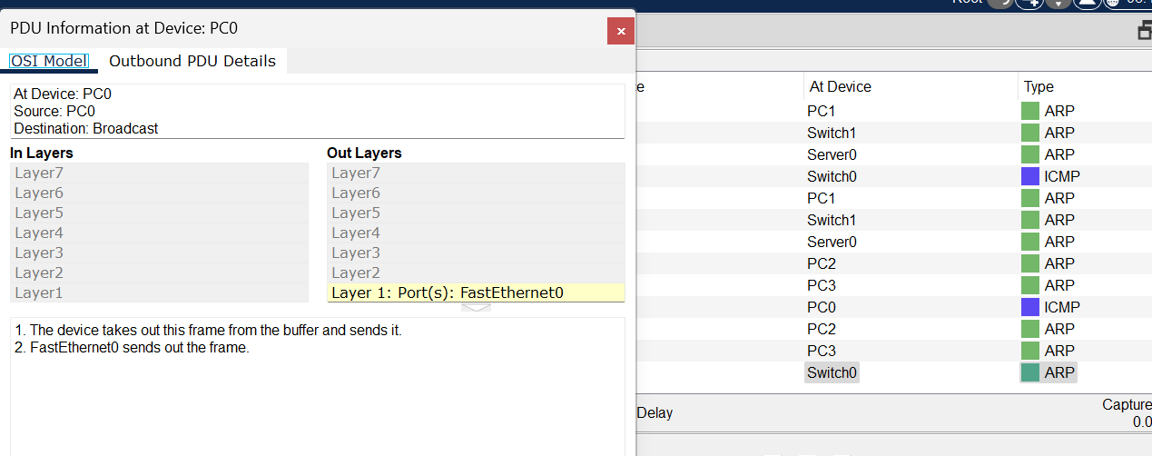

**Task2:**

A switch forwards data only to the intended device using MAC addresses, which makes it faster and reduces collisions, while a hub broadcasts data to all devices, causing more traffic, collisions, and inefficiency.

**Task3:**

The **physical mode** shows the real-world layout of the network, including the actual devices such as PCs, switches, routers, and the cables that connect them. It represents how the devices are physically placed and wired together. The **logical mode**, on the other hand, shows how the devices are connected and communicate at the data level. It focuses on the logical flow of data, IP addressing, and the functional connections between devices rather than their physical arrangement.

**Task4:**

Segment 1 (PC to Switch) should use a **straight-through** UTP cable because it connects a host to a switch; Segment 2 (Switch to Router) should also use a **straight-through**cable since it connects different device types; and Segment 3 (Router to Router) should use a **crossover** UTP cable because it connects two similar network devices.

**Task5:**

A **bridge** links two sections of a network and checks the MAC addresses to decide where data should go. The first time a device sends data, the bridge doesn’t know which way to forward it, so it floods the data to all devices. While doing that, it records the sender’s address and the port it came from. Later, when data needs to reach the same destination, the bridge already knows the correct path and forwards it only there. This helps cut down extra traffic and makes the network work more efficiently.

1. Checking connectivity

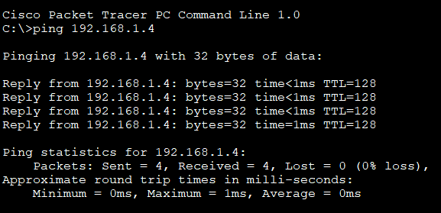

1. When we pinged PC7 from PC0 (IP: 192.168.1.5), the bridge did not know the destination MAC address at first. Because of this, it flooded the packet to both sides of the network. While doing so, it learned the **source MAC address of PC0** and stored it in its MAC table with the corresponding port. Once PC7 replied, the bridge also learned PC7’s MAC address and the port it belongs to. From that moment onward, the bridge no longer needed to flood the packets. It forwarded the communication only between PC0 and PC7, reducing unnecessary traffic and showing how bridges improve efficiency compared to hubs.

